# PORTFOLIO ASSESSMENT GUIDE for

# ECDPT-194B: Observation Internship

**What is a Portfolio**:

A Portfolio is a formal means of requesting assessment of your prior work/life experience from which you have developed sufficient college-level learning to earn credit for a specific class.

**Purpose of this Guide**:

This document is intended for student self-assessment purposes only. Review it carefully to determine if you are ready to write and submit a Portfolio for the course indicated above. Your self-assessment is not a guarantee that you will be awarded credit for the course. Faculty with expertise in the subject matter will evaluate whether your Portfolio provides sufficient evidence that you have demonstrated appropriate college-level mastery of the course content through experiential learning.

# General Guidelines:

* All work must be word-processed, except for documentation provided.
* Written portions should demonstrate college-level writing skills, including appropriate citations for any quoted or paraphrased material from other sources.
* Use the provided template, located on **page 3** of the guide, to format the portfolio appropriately.
* Your Portfolio will not be returned. Make copies of the contents before you submit. You may include clear copies of documentation and keep the originals.
* Submit your completed Portfolio, along with the approved Course Portfolio Assessment Form, to the Adult Learning Programs Office.

# Determination of Portfolio Assessment Outcome:

You will need to do the following to be awarded credit through Portfolio Assessment for this course:

* **Students must submit a portfolio for ECDPT 150 Observation & Assessment and have earned credits for that course prior to submitting a portfolio for ECDPT 194B Internship in Early Childhood Development.**
* Provide all required documentation as listed within the portfolio template to support the Learning Outcomes on the provided scoring rubric below.
* Possibly participate in an interview with the Portfolio evaluator.
* Submit your portfolio with indicated examples of evidence listed on the Scoring Rubric to support each of the listed Learning Outcomes. Label each submission, **Learning Outcome 1, Learning Outcome 2,** etc. You must earn a 3 or higher for each of the Learning Outcomes provided in the Scoring Rubric.
* Internship credits are based on the number of hours dedicated to working in an early childhood classroom performing the tasks of observation, assessment, curriculum planning, and family engagement. See the Scoring Rubric below for examples of verifying documentation.
* Earn a 3 or higher on at least seven of the nine learning outcome essay questions (based on the rubric provided below)

|  |  |
| --- | --- |
| 1  Does not Meet  Expectations | Evidence demonstrates very low level of mastery of this outcome. The evidence is unconvincing, incomplete, very inadequate, contains many inaccuracies, and/or is marked by major conceptual problems. |
| 2  Needs Improvement | Evidence demonstrates inadequate mastery of this outcome. Although some aspects of the work may be acceptable, too much of the evidence is unconvincing, incomplete, inadequate, contains multiple inaccuracies,  and/or demonstrates major conceptual problems. |
| 3  Adequately Meets  Expectations | Evidence demonstrates adequate mastery of this outcome. Although it is not perfect, the work is fairly complete, accurate, and free of major conceptual problems. |
| 4  Exceeds Expectations | Evidence demonstrates sophisticated mastery of this outcome. Work is complete, accurate, and free of conceptual problems. |

|  |  |
| --- | --- |
| ECDPT-194B: Portfolio Assessment Scoring Rubric | |
| Learning Outcomes: Credit for this internship will be based on hands-on use of observation, documentation, and assessment on an on-going basis in an early childhood classroom. Most of these learning outcomes will be supported through evidence provided for ECDPT-150 Observation & Assessment.  Since these are internship credits, evidence in the form of hours spent in the early childhood classroom engaged in ongoing observation, documentation, and assessment will be taken into consideration. | Score |
| **Learning Outcome 1**  Demonstrated ability to integrate concepts, language, and classroom learning of observation and assessment in a real-world classroom environment.   * **Evidence Examples:** Each internship credit represents 45 hours directly in the early childhood classroom. ECDPT 194B is a two-credit internship. Documentation provided must include evidence of 90 total hours spent directly in an early childhood classroom verified by an employer.   + Time cards, contracts, letters from supervisors |  |
| **Learning Outcome 2**  Practice and refine professional skills and dispositions related to observation, documentation, and assessment and to promote development and learning of young children across the entire developmental period of early childhood (birth through kindergarten entry).   * Evidence Examples: Any trainings and ongoing professional development related to developing skills in observation, documentation, and assessment as well as hands-on experience in the classroom.   + Supervisor Evaluations, Training Certificates, job description |  |
| **Learning Outcome 3**  Demonstrated practice in strengthening observation skills in the early childhood classroom and use of a variety of documentation tools to record observations in all areas of development   * This would be evident in ongoing professional development training and hands-on experience in the classroom using a variety of tools.   + Supervisor Evaluations, training certificates, job description |  |
| **Learning Outcome 4**  Demonstrated practice using observations to create developmentally appropriate learning activities that extend children’s growth and development in all domains of development   * Appropriate evidence would include lesson plans supporting children’s growth and development in all domains of development**.**    + Supervisor evaluations, job description, lesson plan examples |  |
| **Learning Outcome 5**  Practice appropriate communication skills with peers, staff, families, and children   * Evidence Examples: Describe ways that you collaborate with peers, staff, families and children to assess each child’s growing skills and create appropriate learning opportunities to support further development.   + Supervisor Evaluations, Time Cards, Job Description |  |
| **Trainings, formal education, and experience will also be considered as support for meeting these learning outcomes. Any documentation for training hours/education must be specific to ECDPT194B Internship for Observation, Assessment and Documentation** |  |
| Total Score |  |

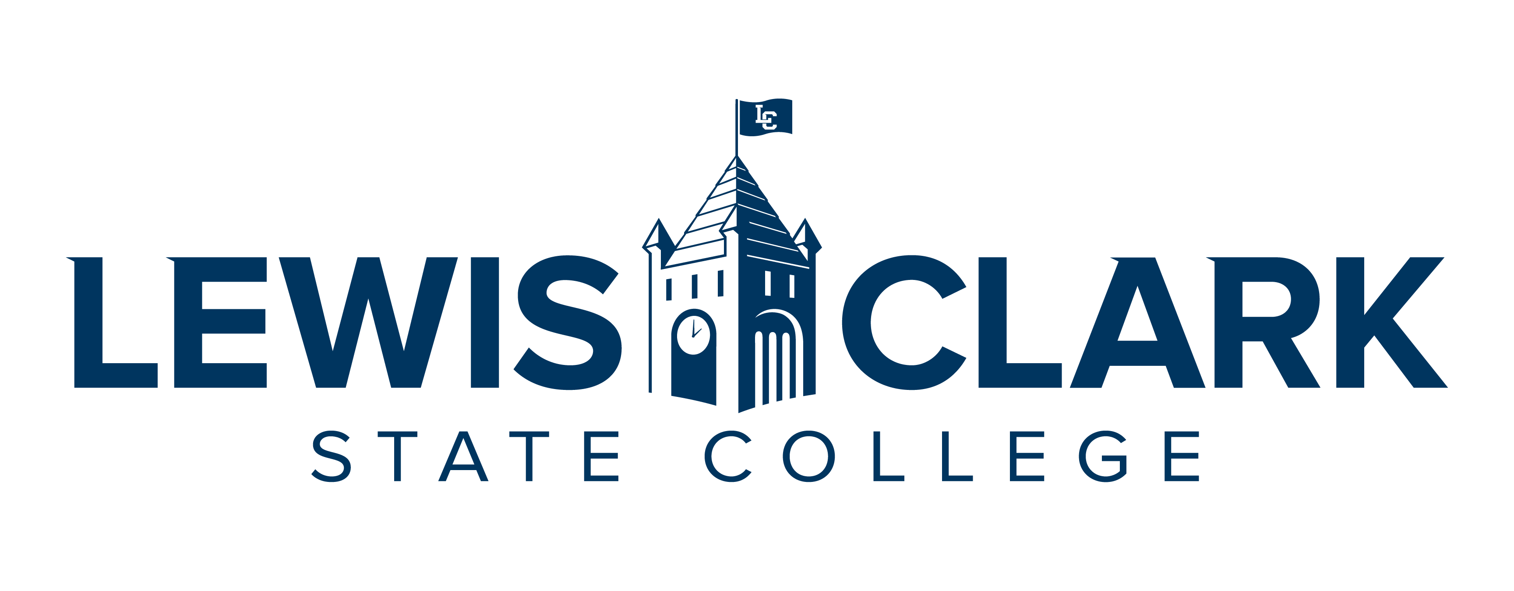

CREDIT FOR PRIOR LEARNING PORTFOLIO

[COURSE NUMBER AND TITLE]

[DATE]

BY

[YOUR NAME]

Table of Contents

Contents

Statement of Academic Honesty 3

Course Description 4

Learning Outcomes 4

Educational Goals 4

Chronological Resume 5

Learning and Experience Autobiography 6

Acquired Learning and Knowledge Narrative 7

Bibliography 8

Documentation 8

Statement of Academic Honesty

The material contained in this Portfolio honestly and accurately reflects my life, learning, and work experience. I understand that the penalty for falsifying any information or documentation will result in an award of no credit for the Portfolio with no resubmission allowed and may result in other sanctions as described in the Student Code of Conduct.

Print Name LCSC ID Number

_____________________________ ____________________

Signature Date

Course Description

ECDPT-194B: Internship

These courses are designed to promote the student’s successful transition from being a student of early childhood education to becoming a practicing, professional early childhood educator with recognized competencies. Teachers will practice skills learned through their content courses to fulfill the goals, outcomes, standards, and ending expectations for an early childhood classroom.

Learning Outcomes

1. Design, implement, and evaluate a variety of developmentally appropriate, evidence-based learning opportunities and strategies for working with young children. (NAEYC Standard: 4c and 5c)
2. Use knowledge of development to create healthy, respectful, supportive, and challenging learning environments that support each child. (NAEYC Standard: 1c)
3. Demonstrate developmentally appropriate, evidence-based guidance interactions to use with young children. (NAEYC Standard: 4c)
4. Practice a variety of assessment techniques in partnership with families and other professionals. (NAEYC Standards: 3b, 3c, and 3d)
5. Demonstrate professional skills: collaboration, problem solving, commitment to NAEYC Code of Ethics, ability to follow policies, and dispositions of effective teachers including sensitivity to culture, language, and ability. (NAEYC Standard: 6b)
   1. Practice appropriate communication skills with peers, staff, families, and children. (NAEYC Standard: 2b)
   2. Practice self-reflection as a tool to improve teaching ad interactions with each child and family. (NAEYC Standard: 6c and 4d)

Educational Goals

**Goals, Motivation, and Time Frame**

What are your goals? What are the reasons (professional and personal) you are pursuing your goals? What is a realistic time frame for completing your education?

**Prior Learning to Goals**

How will the prior learning credit you are requesting fit into your future educational and career goals?

Chronological Resume

Include a chronological resume that will support your request for prior learning. List all jobs held, including volunteer work, as they relate to the course that you are trying to receive credit. List duties, skills and expertise used in performing job tasks. When possible, use language similar to that used in the Learning Outcomes for the course.

Examples of Experience:

* Employment, Work Experience
* Workshops, Webinars, Training, Seminars, Professional Development
* Volunteer Activities, Community Service, Committees, Groups
* Military Experience, Occupations, Training
* Licenses, Certificates, Industry Credentials
* Non-credit Courses
* Publications

Learning and Experience Autobiography

The autobiography will serve as an introduction to the evaluator and help them understand the context of your learning for the particular course you are requesting. It is a complete picture of you and your experiences as it relates to the course for which you are creating this portfolio. Relate the relevant experiences to the course in a general explanation (Specifics will be included in the Acquired Learning and Knowledge Narrative). Demonstrate why you have selected this particular course and detail your work and life experiences using your resume as a guide.

This should be two+ pages and summarize the significant learning experiences in your life and describe how your experiences will validate your knowledge of the course content and meet the course outcomes being petitioned for credit.

Acquired Learning and Knowledge Narrative

The narrative is a detailed explanation of how your activities and the resulting competencies were achieved. This is to complement your resume and autobiography. Be sure to link your accomplishments to the course learning outcomes. This will be similar to your autobiography but will detail your chronological work and life experience history while focusing on the things you have already learned through training and experiences, as it relates to your target course.

Note that a key goal of this section is the learning process itself as you reflect on how your experience relates to key concepts within the learning outcomes in the target course. Clearly focus on the learning objectives (what you know and can do) rather than the experience.

* Label each heading, Learning Outcome 1, Learning Outcome 2, etc.
* Include the experience; time spent in activity; description of duties and activities.
* Describe the learning and how it relates to the Learning Outcomes for the course.
* Describe how the learning was acquired.
* Provide documentation as evidence of the experience in relation to the course learning outcomes, and as an indication of the level and appropriateness of content.
* Describe how this experience has influenced and impacted other areas of your life.

This will be 2+ pages in length. Make sure it is clear, concise, and free of errors in sentence structure, grammar, and spelling. It needs to demonstrate college-level writing and critical thinking.

Bibliography

**This is not required.** The bibliography will include any reading done on the course subject. If you have studied manuals or used other texts to gain your prior learning, include them here. References should be cited in American Psychological Association (APA) style, but your instructor may suggest another format.

Documentation

Each of your experiences and competencies will require verification (evidence). This evidence can take several forms:

* Completion of training programs, workshops, seminars, etc., may be verified through:
  + Certificates
  + Personnel records
* Performance reviews showing competencies
* Job descriptions
* Transcripts
* Samples of work
* A videotape of your speech, theatre work, or music recital
* Licenses
* Honors or Awards
* Samples of your painting, drawing, photography, or ceramics for a studio art course
* Certificates of attendance
* Letters of verification listing proven competencies from instructors or employers
* Products designed or created by you
* Military records

Each piece of documentation for a workshop or training program must be accompanied by a description page of content for each workshop, training program, or seminar and must show how the evidence relates to the course learning outcomes.