

**Camps/Events Checklist & Guide**

1. **Pre-Camp/Event Activities**
2. Set Dates/Times of Camp/Event

1. Minimum 60 days prior to the start of the camp/event, coordinate with Events & Conferences and Athletics Facility Manager to finalize dates and times requested for camp/event. When dates and times are confirmed, register in 25Live.

* Date and time confirmed
* Camp/event entered in 25Live
* ATHLETICS ONLY: A camp authorization form must be completed and signed by the head coach, facility manager and athletic director (see attached *Camp Authorization Form*).

2. For Athletics Camps: Hometown/database registration can begin once the camp registration form has been signed and confirmed by the athletic director, facility manager, and head coach. Hometown Registration instructions are attached (see attached form: *Hometown-How to Create an Event)*.

* Hometown Registration initiated

1. Advertising, Promotion, Sponsorship

1. Contact College Advancement, Communications & Marketing, and the Sports Information Director (SID) with the correct camp/event information prior to contacting sponsors, distributing printed materials and posting the event on the LC State Webpage.

* Contacted College Advancement about sponsors
* Contacted Communications & Marketing about print materials
* Contacted SID and provided flyer and any other pertinent information regarding the proposed camp/event.

1. Insurance
2. The office administrative coordinator for the Athletic Department will create a requisition in Jaggaer for the estimated cost of insurance coverage and then submit the *Insurance Request Form* (see attached *Insurance Request Form*) to Administrative Services no later than two weeks prior to the camp/event.

* Requisition entered in Jaggaer
* Insurance Request Form submitted to Administrative Services

A separate Insurance Request Form must be submitted for each camp/event.

1. Cash Box
2. If the camp/event requires a cash box, a cash box request form (see attached *Cash Box Agreement* form) must be completed and sent to the office administrative coordinator of the Athletic Department no less than 10 days prior to the event.

* Completed Cash Box Agreement form

1. **Camp/Event Workers and Volunteers**
2. Email the roster of workers (see attached *Background Check and Training Roster* form), a minimum 30 days prior to the camp/event, to the office of Events & Conferences. List each individual who will be working for your camp or event. See “Minors on Campus" guidelines (https://www.lcsc.edu/event-services/minors-on-campus-policy) for requirements. **See Section D below for** ***Requirements for Volunteers.***

* Emailed roster to Events & Conferences

1. Camp/event workers will receive an email to complete a background check and training. This email often goes to the individuals spam/junk folder. Please check all folders in inbox.
2. Camp/event workers must have completed safety training and completed a background check prior to the start of camp/event
3. Workers who are non-LC State employees or students

A non-LC Employee must complete and sign a *Memorandum of Agreement (*MOA) (see attached *Blank MOA* form) before the start of the camp/event. The MOA Process of Approvals includes:

1. MOA created and sent to athletic director with no signatures;
2. Athletic Director sends written approval (no signature) to VPFA;
3. VPFA signs and returns to head coach;
4. Head coach sends to employee for review and signature;
5. Employee signs and returns to coach. Coach uploads to designated server folder.

A *Personnel Record Card (PRC)* must be completed for a student worker before the start of the camp/event. The PRC must be signed by the head coach and the athletic director, then forwarded to the Human Resource Services office.

When initially hiring a worker who has not been previously employed by the school, a PaymentWorks invite will need to be completed. The new vendor will receive an email requesting completion of information to become a vendor in our system.

1. Workers who are LC State Employees
2. MOA created by head coach and sent to athletic director with no signatures;
3. Athletic director reviews, signs, and returns to head coach;
4. Head coach sends to employee for review and signature;
5. LC State employee signs and returns to head coach;  
   a. If LC State employee is the head coach, he/she signs the MOA and sends to Athletic Department administrative coordinator. (See #5)
6. Head coach then sends MOA to the administrative coordinator to attach to the Personnel Action (PA) form for payment at the conclusion of the camp. The MOA will be kept in a designated folder on the server.
7. Camp/Event Volunteers

Email the roster of volunteers (see attached *Background Check and Training Roster* form), a minimum 30 days prior to the camp/event, to the office of Events & Conferences. List each individual who will be volunteering for your camp or event. See “Minors on Campus" guidelines (https://www.lcsc.edu/event-services/minors-on-campus-policy) for requirements.

* Emailed roster to Events & Conferences

1. Individuals who volunteer at the camp/event are performing services without compensation.
2. Individuals who volunteer to assist at the camp/event must complete the *Volunteer Services Agreement* (see attached *Volunteer Services Agreement*).
3. Volunteers working with minors, must complete a Background Check Authorization Form (see attached *Background Check Authorization Form*).
4. Volunteers driving LC State vehicles must complete a Vehicle Use Agreement form (see attached *Vehicle Use Agreement form*), submit to a driver’s background check, and take any required training.
5. **Registration of Camp Participants**
6. A parent or guardian of the minor camp participant must complete the Parent-Guardian Permission Form (see attached *Parent Guardian Permission Form for Minors on Campus*) prior to the start of camp/event and submit it to the Athletic Department. The form can also be completed and submitted the first day of camp/event, to allow the minor participant to begin camp/event. The Athletic Department will collect the forms and submit them to Events & Conferences.

* Received completed/signed Permission Forms

For more information on Minors on Campus please visit: [https://www.lcsc.edu/event- services/minors-on-campus-policy](https://www.lcsc.edu/event-services/minors-on-campus-policy)

1. **During Camp/Event**
2. Check-in/Check-out Process for Participants

All minors MUST be checked in and out of the camp/event. A designated camp staff member is responsible for arrival and departure. After the camp/event, an arrival and departure report, generated from the Hometown Registration database, is submitted to Events & Conferences.

* Submitted Hometown Participant arrival/departure report to Events & Conferences

1. **Post-Camp/Event Activities**
2. **Completed Activity Report**

The “Completed Activity Report” form (see attached *Completed Activity Report* form) must be filled out and submitted to Administrative Services immediately upon completion of the camp/event. Administrative Services will obtain an invoice from the insurance company based on the Completed Activity Report information and provide it to the office administrative coordinator for the Athletic Department to enter into the Jaggaer system for payment by the Controller’s office.

* Submitted “Completed Activity Report” to Administrative Services
* Received invoice from insurance company and entered receipt into Jaggaer system.

1. **Athletic Camp Accounting Worksheet**

At the conclusion of camp, the camp accounting worksheet (see attached worksheet template - *Blank Camp Accounting Worksheet*) must be completed and uploaded to the Athletics server in the designated Camp folder. The Athletic Department business manager will monitor and verify via signature. This worksheet is used for the coach to submit Personnel Action forms for payment to employees who were part of the camp staff. All instructions for completing this form are listed in the attached document.

* Completed Camp Accounting Worksheet
* Uploaded worksheet to designated Camp folder in Athletics server

1. **Payment to Workers of Camp/Event – Entering Workers in Jaggaer System**
2. A Camp/Event Worker who is a non-student and new vendor

When initially hiring a worker (new vendor and non-student) who has not been previously employed by the school, a PaymentWorks invite within the Jaggaer system will need to be completed. Select the “Supplier Request (PaymentWorks)” form on the Dashboard page of Jaggaer. The new vendor will receive an email requesting completion of information to become a vendor in our system.



The PaymentWorks invite drop down needs to be selected below, and all information needs to be supplied.

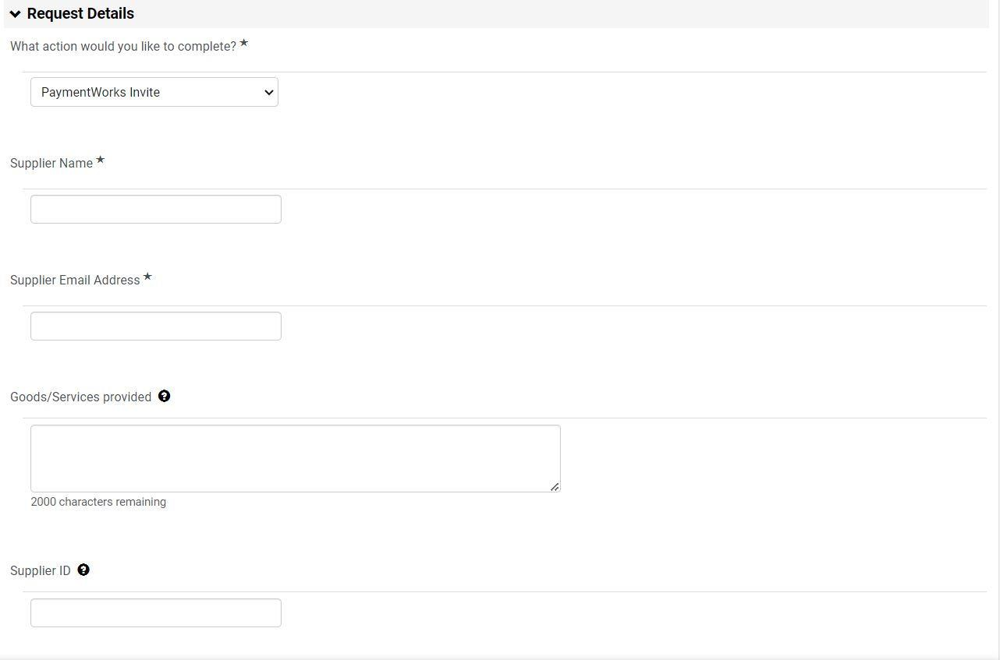

When the vendor registration process is complete, the department will receive an email notification that the Supplier Request Form has been approved and the vendor record will be added to Jaggaer.

1. A Camp/Event worker who is a student (Student as an Independent Contractor)

Select the “Supplier Request (PaymentWorks)” form on the Dashboard page of Jaggaer, then select **student as independent contractor** from the drop-down list and fill in the information.

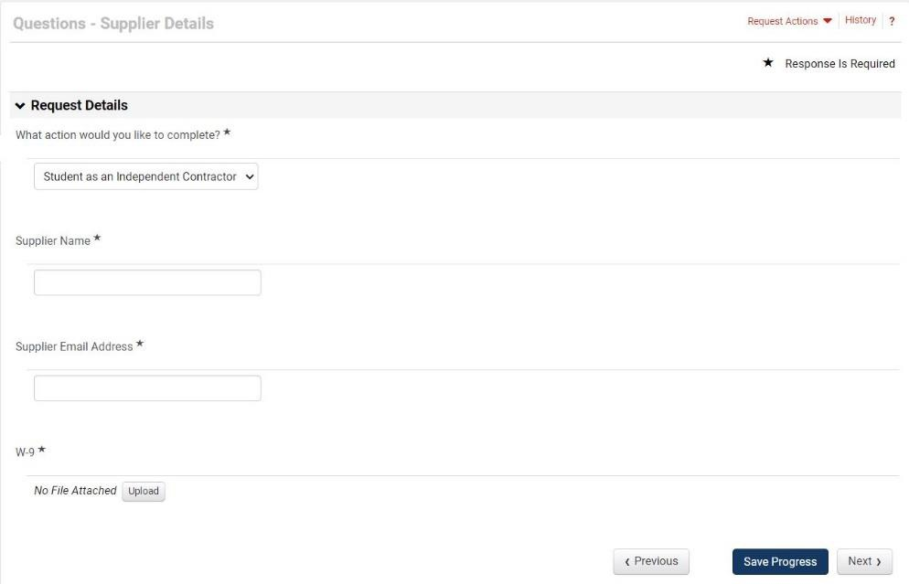

1. **Payment to Non-employee Workers of Camp/Event – Entering the Hours/Wage in Jaggaer System**
2. Payment for **non-employee** or **non-student** worker:
   1. Go to cart and click “View Forms”.
   2. Click “Independent Contractor Request”.
   3. Fill out information below:
   4. Under amount and quantity, do not enter a full lump sum. Make multiple quantities as if you are paying per hour.
      1. Example, $25 per game (amount) and quantity (15 games).
      2. This helps when workers leave or do not show up.

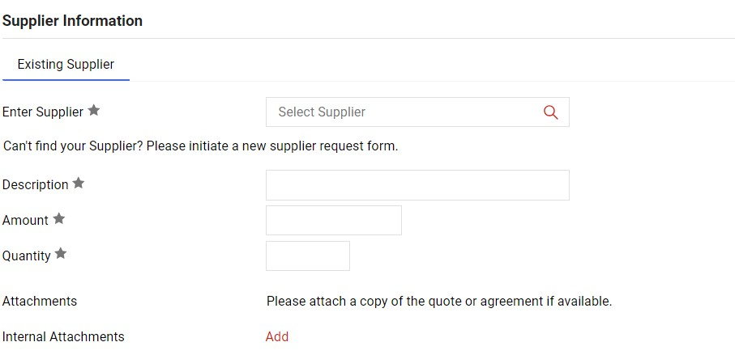

* 1. MOA attachment is inserted under “Add” in red above. Coach will attach the completed MOA to the ICP (Independent Contractor Payment)
  2. Once completed, click “Add and go to cart” in the upper right-hand corner.
  3. Click “Proceed to checkout”.
  4. At this step, designate which budget account will be charged. Budget account numbers can be confirmed with the Athletic Department administrative coordinator or business manager.
  5. Object code MUST be: 5-5199

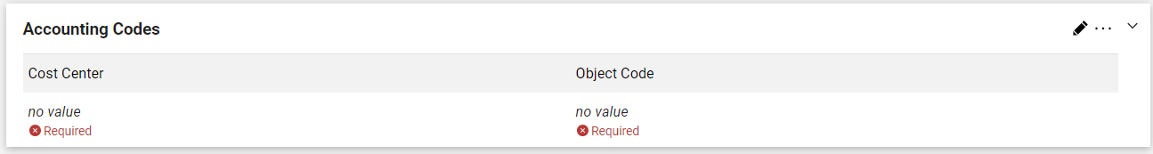

* 1. Select “Place Order” and watch the approvals on the bottom right-hand side of the window.
  2. Once the camp/event is complete, select the ICP from the purchase order list to create a receipt. ONLY receipt for the amount of work completed and attach the fully signed MOA. Create a receipt for each employee after each camp/event. Do not go over the amount on the MOA.

