

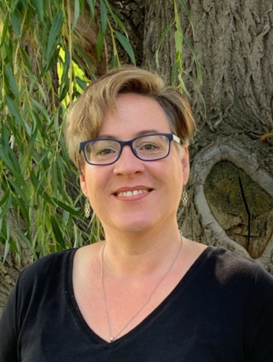

**Jennifer D. Alexander, Ed.D.**

Associate Professor of Education

Office: Spalding, Room 236

E-Mail: [*jdalexander@lcsc.edu*](mailto:jdalexander@lcsc.edu)

Phone: 208-792-2430

|  |  |  |  |  |  |
| --- | --- | --- | --- | --- | --- |
| **Fall 2024**  Dr. Alexander is available during office times indicated below and  **additional times, by appointment.**  Please contact her by email (jdalexander@lcsc.edu) to schedule an appointment. | | | | | |
|  | **Monday** | **Tuesday** | **Wednesday** | **Thursday** | **Friday** |
| * Week 5 of the semester I teach every morning from 8:00 – 11:30 *  ED 426 Fine Arts Methods | | | | | |
| **8:00** | Grade and prep | Grade and prep | Grade and Prep | Interns and prep | Service and Scholarship |
| **9:00** |
| **10:00** | Office Hours | Office Hours |
| **11:00** |
| **12:00** | Grade and prep | Interns and Prep |
| **1:00** |
| **2:00** |
| **3:00** |
| **4:00** |

Courses for FALL 2024:

RE 309 Disciplinary Literacy (online)

RE 342 Intermediate Literacy (online)

ED 425 Instructional Methods & Classroom Mgmt K-8 (online)

ED 426 Fine Arts Methods (MTB 102)