

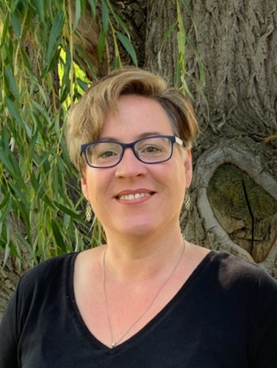

**Jennifer D. Alexander, Ed.D.**

Assistant Professor of Education

Office: Spalding, Room 236

E-Mail: [*jdalexander@lcsc.edu*](mailto:jdalexander@lcsc.edu)

Phone: 208-792-2430

|  |  |  |  |  |  |
| --- | --- | --- | --- | --- | --- |
| **Spring 2025**  Dr. Alexander is available during office times indicated below and  **additional times, by appointment.**  Please contact her by email ([jdalexander@lcsc.edu](mailto:jdalexander@lcsc.edu)) to schedule an appointment. | | | | | |
|  | **Monday** | **Tuesday** | **Wednesday** | **Thursday** | **Friday** |
| **\* Week 4 of the semester I teach every morning from 8:00 – 11:30 \***  **ED 426 Fine Arts Methods in MTB 103** | | | | | |
| **8:00** | Grade and Prep | Grade and Prep | Interns and Prep | Scholarship | Service and Scholarship |
| **9:00** |
| **10:00** |
| **11:00** |
| **12:00** | **Office Hours** | **Office Hours** |
| **1:00** |
| **2:00** |  | Service |
| **3:00** | RE/SE 342  MTB 102 | Division meeting | RE/SE 342  MTB 102 |
| **4:00** |  |

Courses for SPRING 2025

RE 307 Literacy Leadership (online)

RE 309 Disciplinary Literacy (online)

RE 342 Intermediate Literacy (MTB 102)

ED 426 Fine Arts Methods (MTB 103)

ED 426 Fine Arts Methods (online)